**EE 391**

**Homework 1**

**Mert Özerdem**

**ID: 21300835**

**Section: 03**

**Q1)** When frequency of the sinusoidal function is increased pitch of the sound increased as well. I used frequencies f0 equals to 440, 880 and 1760. These all are musical note A but one or more octave higher. You can see the graphs an the code below [see Appendix A].

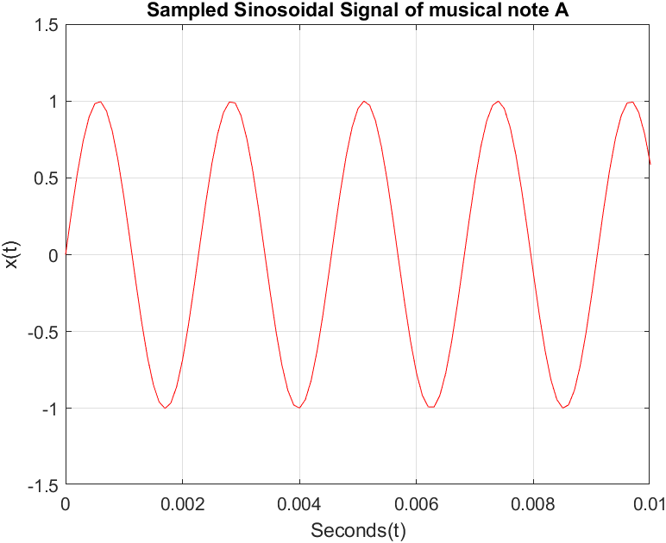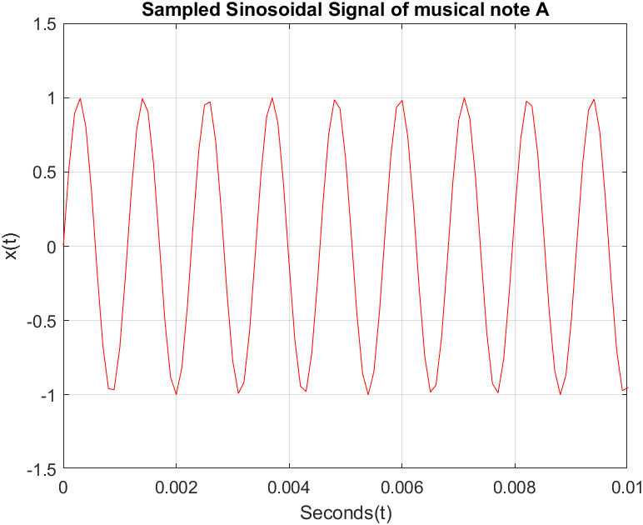

figure 1 : Graph of 440 Hz figure 2: Graph of 880 Hz

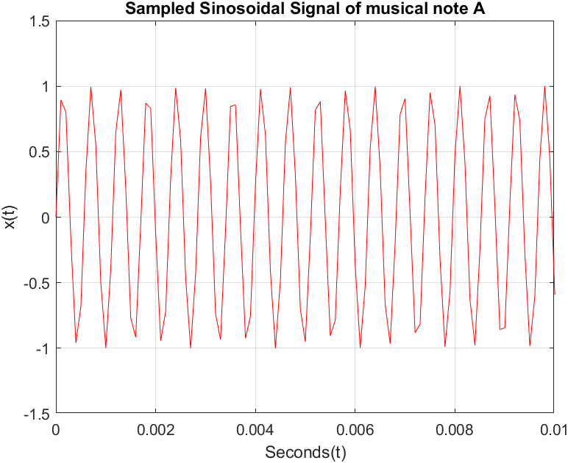

figure 3: Graph of 1760 Hz

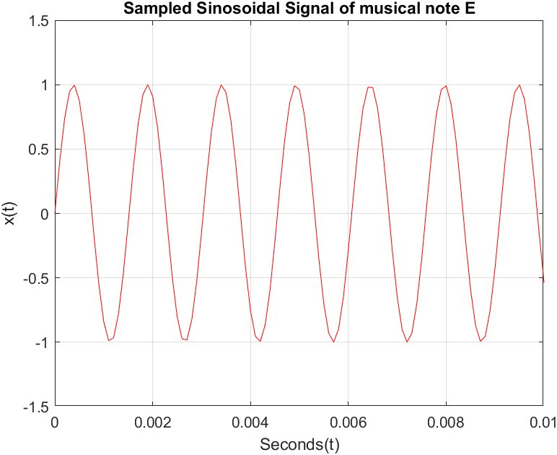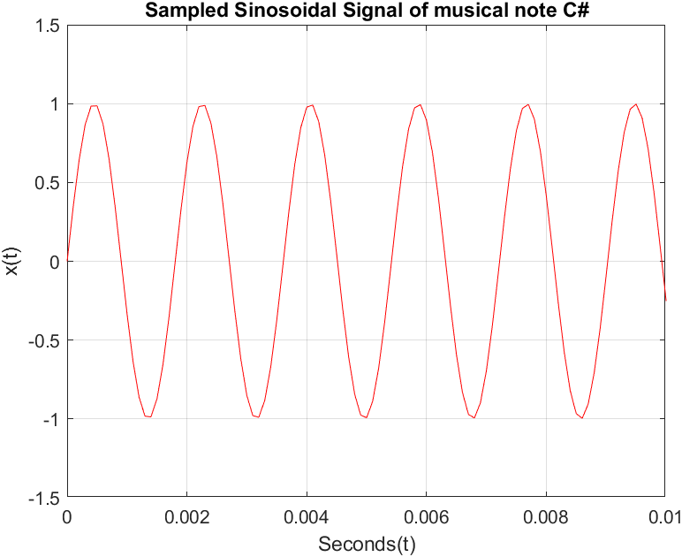

figure 4: Graph of 659 Hz figure 5: Graph of 554 Hz

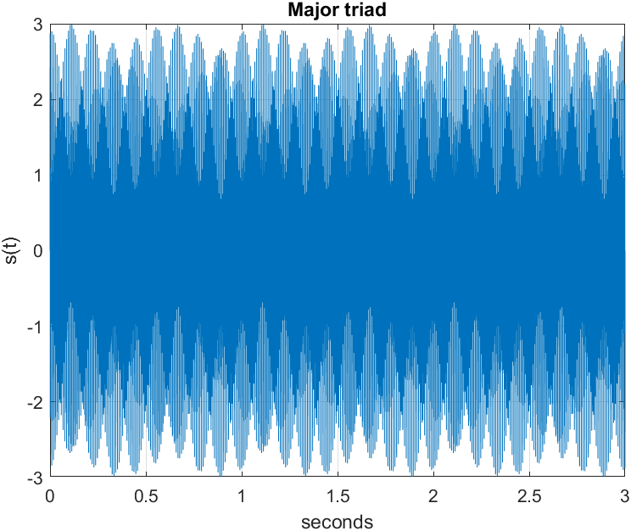figure 6: Major triad

Major triad combined have a harmonic and nice to listen compared to others. Though i do not know what is special about this musical note. I do not have any musical background. For more information about code you can see Appendix A.

**Q2)** **part a)**

In this part phase is equal to 0.[see Appendix B]

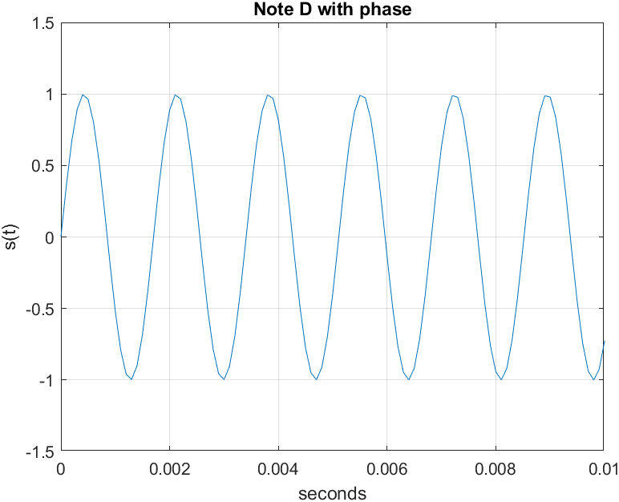

figure 7: Note D with phase 0

**Part b)**

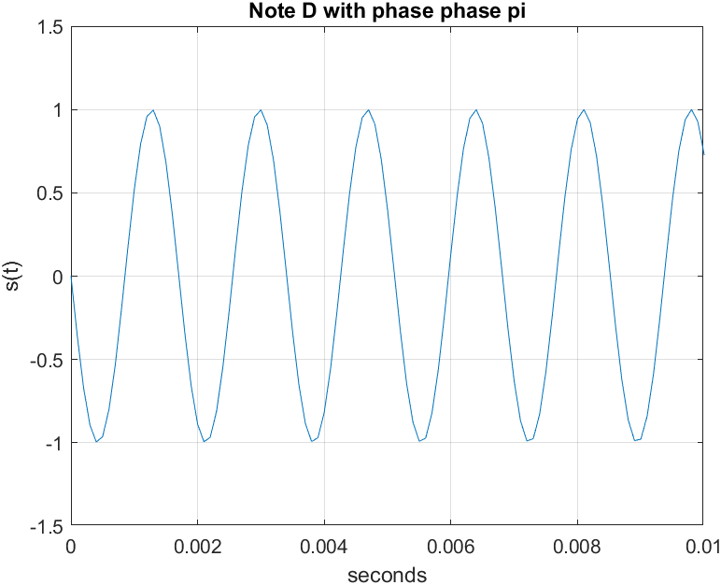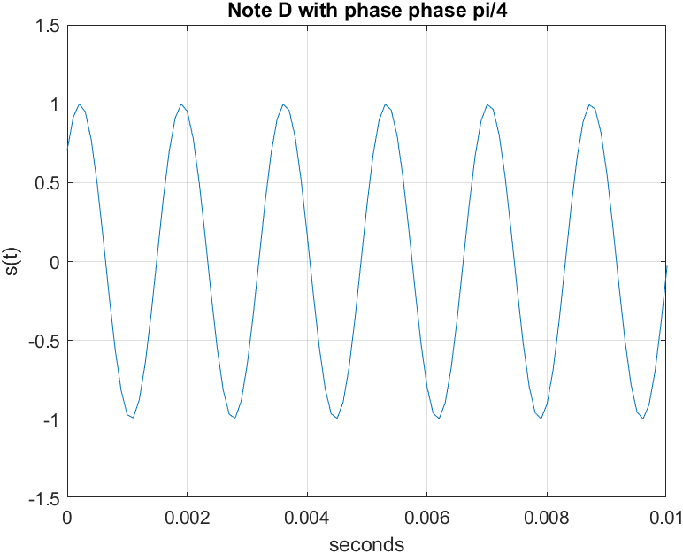

figure 8: Note D with phase pi figure 9: Note D with phase pi/4

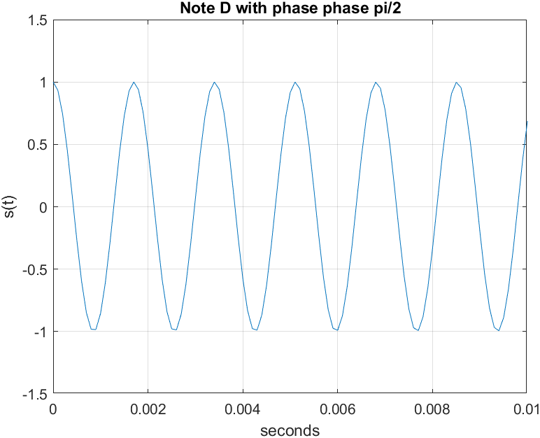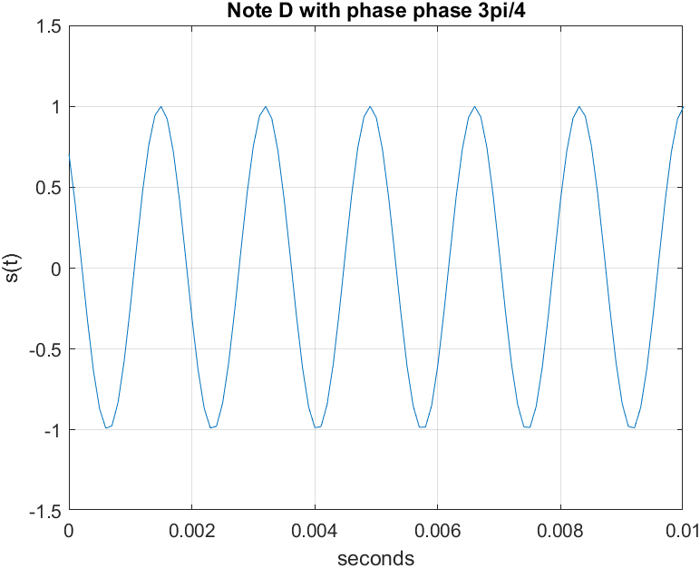

figure 10: Note D with phase pi/2 figure 11: Note D with phase 3pi/4

Pitch of the voice does not change as phase changes. This is also true for volume of the sound. Volume of the sound also seems not changing.[see Appendix B]

**Q3)** This sinusoid has a sound that matches with its graph. Graph suggests that sound should decay less than a second and people will not be able to hear within a half of a second. This happens because of exponential part, which grows as time t increases thus drives the function x(t) to 0 after 1 second. x3(t) function is different from other because it decays over time and gives more pleasing sound. On the other hand x1(t) function resembles piano sound while x2(t) resembles to the flute sound.

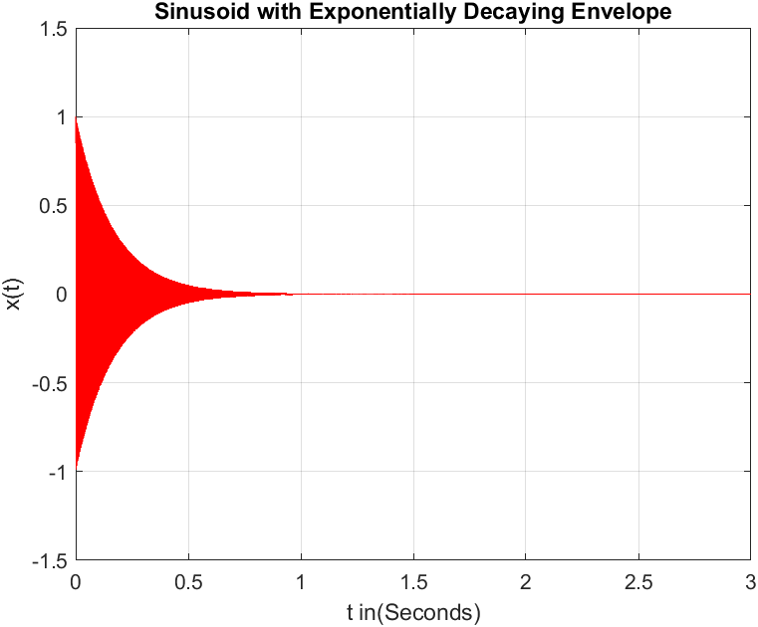

figure 12: a = 2

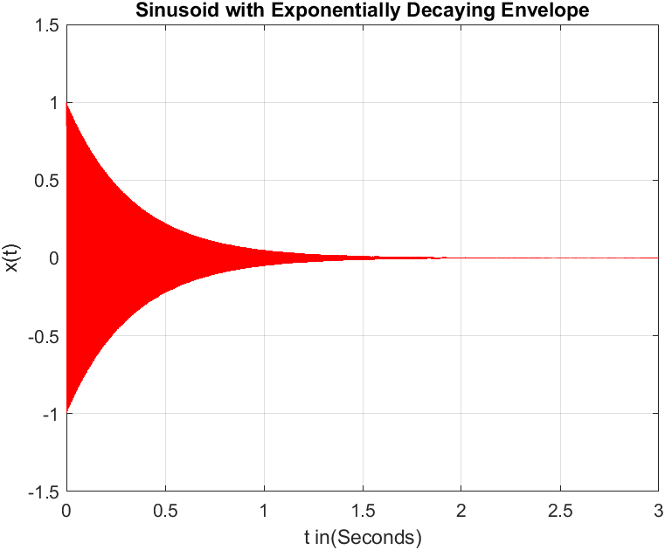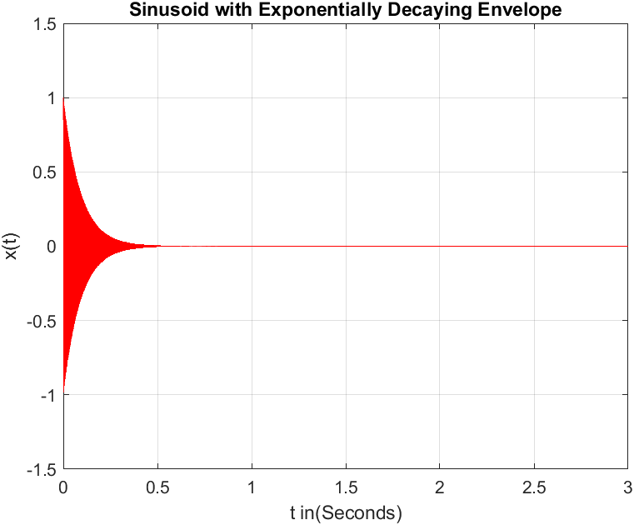

figure 12: a = 1 figure 12: a = 3

As you can see from the graphs as a decreases decay rate also decreases. Thus we can say that, increasing a decreases the duration of the sound. This signal is related with the music and speech signals that decays over time with the air friction and gives a sound smooth sound. Also this signal resembles to the radar and sonar signals that decay over time. [see Appendix C]

**Q4)** Beat Note is different than the x1(t) function because we can hear that sound decays and goes higher until to end. We can also see the from the graph x4(t) value grows than decays over and over again until the end of the signal. With the addition of the low frequency cosine term this is possible. If we decrease the f1 low frequency sound becomes more similar to the sound in the x1(t) signal. And if we increase it frequency it becomes something different. [see Appendix D]

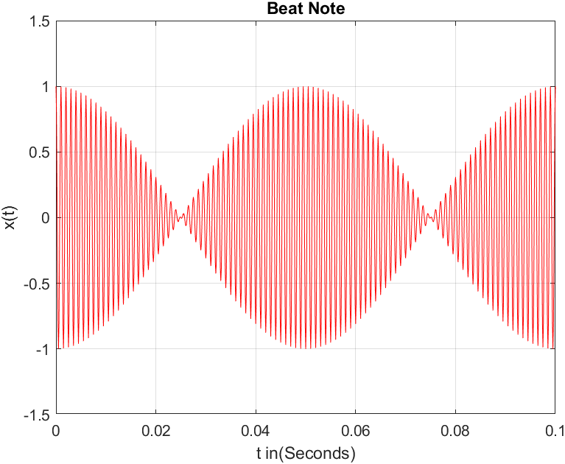

figure 13: Beat Note with frequency f1 = 10Hz

x4(t) = cos(2πf1t)cos(22πf2t)

x4(t) =½[cos(2πt(f1+f2)) + cos(2πt(f1-f2))]

From this equation we can see that x4 signal is the combination of 1010 Hz and 990 Hz two signals.

**Q5)** I calculated μ to be first -500 then 500. I run both signals but i did not notice any difference between sounds. But when i doubled the μ it seem that volume of the sound lowered. And when i decreased the μ volume of the sound increased.[see Appendix E]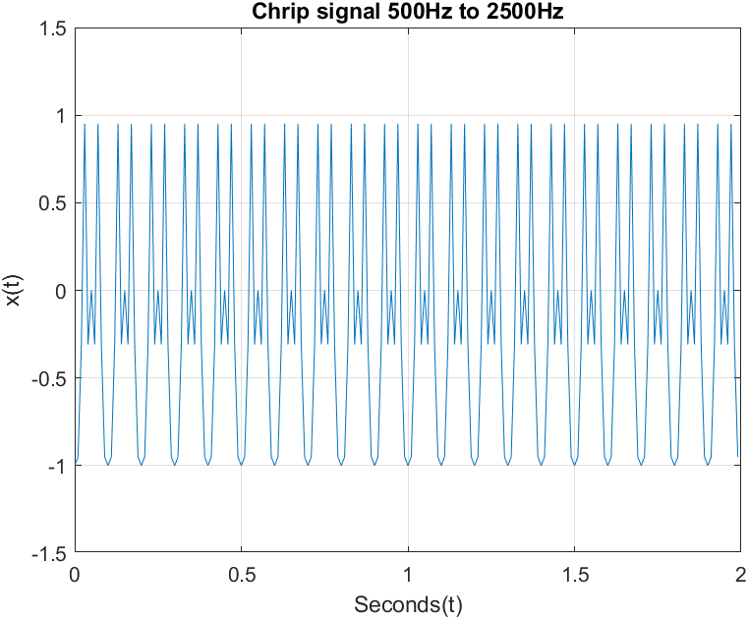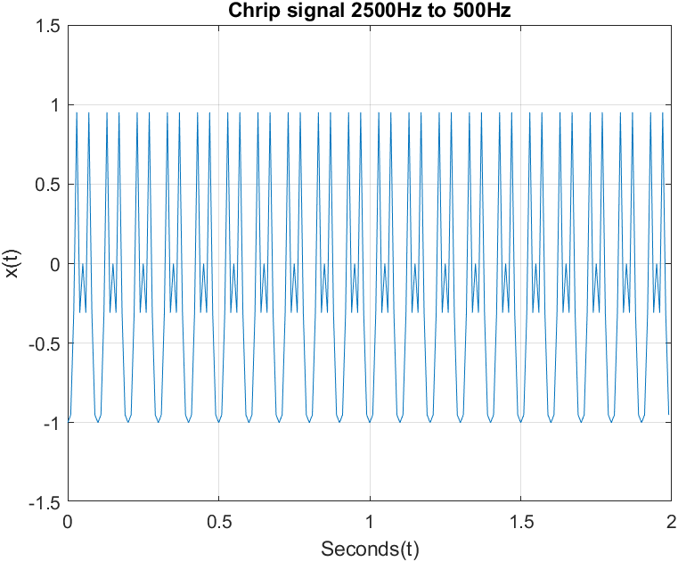

**Chirp puzzle**

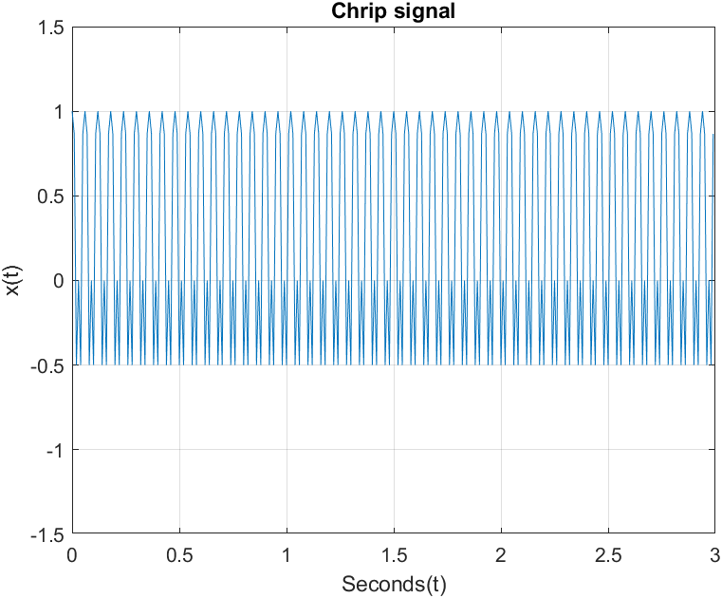

**Q6)** My musical piece is at the end of the report. You can check it in the appendix.[see Appendix F]

Appendices

# Appendix A

**Code of 440 Hz**

%%%%%%%%%%%%%%%%%%%%%%%%%%%%%%%

a = 1; %frequency multiplier

f0 = a*440; %440 fundemental frequency

w0 = 2*pi*f0;

Ts = 0.0001; %time interval between samples

n=0:Ts:3-Ts; % sample space

x1=sin(w0*n); % signal (sampled)

%set = 0.01/30000;

%t=0:set:0.01-set;

plot(n,x1,'-r');

xlim([0 0.01]);

ylim([-1.5 1.5]);

grid on;

xlabel('Seconds(t)');

ylabel('x(t)');

title('Sampled Sinosoidal Signal of musical note A');

sound(x1);

%%%%%%%%%%%%%%%%%%%%%%%%%%%%%%%

**Code of 880Hz**

%%%%%%%%%%%%%%%%%%%%%%%%%%%%%%%

a =4; %frequency multiplier

f0 = a*440; %440 fundemental frequency

w0 = 2*pi*f0;

Ts = 0.0001; %time interval between samples

n=0:Ts:3-Ts; % sample space

x1=sin(w0*n); % signal (sampled)

%set = 0.01/30000;

%t=0:set:0.01-set;

plot(n,x1,'-r');

xlim([0 0.01]);

ylim([-1.5 1.5]);

grid on;

xlabel('Seconds(t)');

ylabel('x(t)');

title('Sampled Sinosoidal Signal of musical note A');

sound(x1);

%%%%%%%%%%%%%%%%%%%%%%%%%%%%%%%

**Code of 1760 Hz**

%%%%%%%%%%%%%%%%%%%%%%%%%%%%%%%

a = 2; %frequency multiplier

f0 = a*440; %440 fundemental frequency

w0 = 2*pi*f0;

Ts = 0.0001; %time interval between samples

n=0:Ts:3-Ts; % sample space

x1=sin(w0*n); % signal (sampled)

%set = 0.01/30000;

%t=0:set:0.01-set;

plot(n,x1,'-r');

xlim([0 0.01]);

ylim([-1.5 1.5]);

grid on;

xlabel('Seconds(t)');

ylabel('x(t)');

title('Sampled Sinosoidal Signal of musical note A');

sound(x1);

%%%%%%%%%%%%%%%%%%%%%%%%%%%%%%%

**Code of 554 Hz**

%%%%%%%%%%%%%%%%%%%%%%%%%%%%%%%

a = 1; %frequency multiplier

f0 = a*554; %440 fundemental frequency

w0 = 2*pi*f0;

Ts = 0.0001; %time interval between samples

n=0:Ts:3-Ts; % sample space

x1=sin(w0*n); % signal (sampled)

%set = 0.01/30000;

%t=0:set:0.01-set;

plot(n,x1,'-r');

xlim([0 0.01]);

ylim([-1.5 1.5]);

grid on;

xlabel('Seconds(t)');

ylabel('x(t)');

title('Sampled Sinosoidal Signal of musical note A');

sound(x1);

%%%%%%%%%%%%%%%%%%%%%%%%%%%%%%%

**Code of 659 Hz**

%%%%%%%%%%%%%%%%%%%%%%%%%%%%%%%

a = 1; %frequency multiplier

f0 = a*659; %440 fundemental frequency

w0 = 2*pi*f0;

Ts = 0.0001; %time interval between samples

n=0:Ts:3-Ts; % sample space

x1=sin(w0*n); % signal (sampled)

%set = 0.01/30000;

%t=0:set:0.01-set;

plot(n,x1,'-r');

xlim([0 0.01]);

ylim([-1.5 1.5]);

grid on;

xlabel('Seconds(t)');

ylabel('x(t)');

title('Sampled Sinosoidal Signal of musical note A');

sound(x1);

%%%%%%%%%%%%%%%%%%%%%%%%%%%%%%%

**Major Triad**

%%%%%%%%%%%%%%%%%%%%%%%%%%%%%%

t= 0:0.0001:3;

s = sin(2*pi*440*t) + sin(2*pi*554*t) + sin(2*pi*659*t);

plot(t,s);

grid on;

xlabel('seconds');

ylabel('s(t)');

title('Major triad');

soundsc(s);

%%%%%%%%%%%%%%%%%%%%%%%%%%%%%%

# Appendix B

**Note D with phase 0**

%%%%%%%%%%%%%%%%%%%%%%%%%%%%%%

t= 0:0.0001:3;

Phase = 0;

s = sin(2*pi*587*t + Phase);

plot(t,s);

grid on;

xlabel('seconds');

ylabel('s(t)');

title('Note D with phase');

xlim([0 0.01]);

ylim([-1.5 1.5]);

soundsc(s);

%%%%%%%%%%%%%%%%%%%%%%%%%%%%%%

**Note D with phase 3pi/4**

%%%%%%%%%%%%%%%%%%%%%%%%%%%%%%

t= 0:0.0001:3;

Phase = 3*pi/4;

s = sin(2*pi*587*t + Phase);

plot(t,s);

grid on;

xlabel('seconds');

ylabel('s(t)');

title('Note D with phase phase 3pi/4');

xlim([0 0.01]);

ylim([-1.5 1.5]);

soundsc(s);

%%%%%%%%%%%%%%%%%%%%%%%%%%%%%%

**Note D with phase pi/4**

%%%%%%%%%%%%%%%%%%%%%%%%%%%%%%

t= 0:0.0001:3;

Phase = pi/4;

s = sin(2*pi*587*t + Phase);

plot(t,s);

grid on;

xlabel('seconds');

ylabel('s(t)');

title('Note D with phase phase pi/4');

xlim([0 0.01]);

ylim([-1.5 1.5]);

soundsc(s);

%%%%%%%%%%%%%%%%%%%%%%%%%%%%%%

**Note D with phase pi/2**

%%%%%%%%%%%%%%%%%%%%%%%%%%%%%%

t= 0:0.0001:3;

Phase = pi/2;

s = sin(2*pi*587*t + Phase);

plot(t,s);

grid on;

xlabel('seconds');

ylabel('s(t)');

title('Note D with phase phase pi/2');

xlim([0 0.01]);

ylim([-1.5 1.5]);

soundsc(s);

%%%%%%%%%%%%%%%%%%%%%%%%%%%%%%

**Note D with phase pi**

%%%%%%%%%%%%%%%%%%%%%%%%%%%%%%

t= 0:0.0001:3;

Phase = pi;

s = sin(2*pi*587*t + Phase);

plot(t,s);

grid on;

xlabel('seconds');

ylabel('s(t)');

title('Note D with phase phase pi');

xlim([0 0.01]);

ylim([-1.5 1.5]);

soundsc(s);

%%%%%%%%%%%%%%%%%%%%%%%%%%%%%%

# Appendix C

**x3(t) exponential decay envelope function with a = 2**

%%%%%%%%%%%%%%%%%%%%%%%%%%%%%%

f0 =440;

a = 2;

t=0:0.0001:3;

x3 = (exp(-((a^2)+2)*t)).*cos(2*pi*f0*t);

plot(t,x3,'-r');

xlim([0 3]);

ylim([-1.5 1.5]);

grid on;

xlabel('t in(Seconds)');

ylabel('x(t)');

title('Sinusoid with Exponentially Decaying Envelope');

soundsc(x3);

%%%%%%%%%%%%%%%%%%%%%%%%%%%%%%

# Appendix D

**With Frequency f1 10 Hz**

%%%%%%%%%%%%%%%%%%%%%%%%%%%%%%

f1 = 10;

f2 = 1000;

t=0:0.0001:3;

x4 = cos(2*pi*f1*t).*cos(2*pi*f2*t)

plot(t,x4,'-r');

xlim([0 0.1]);

ylim([-1.5 1.5]);

grid on;

xlabel('t in(Seconds)');

ylabel('x(t)');

title('Beat Note');

soundsc(x4);

%%%%%%%%%%%%%%%%%%%%%%%%%%%%%%

**With Frequency f1 5 Hz**

%%%%%%%%%%%%%%%%%%%%%%%%%%%%%%

f1 = 5;

f2 = 1000;

t=0:0.0001:3;

x4 = cos(2*pi*f1*t).*cos(2*pi*f2*t)

plot(t,x4,'-r');

xlim([0 0.1]);

ylim([-1.5 1.5]);

grid on;

xlabel('t in(Seconds)');

ylabel('x(t)');

title('Beat Note');

soundsc(x3);

%%%%%%%%%%%%%%%%%%%%%%%%%%%%%%

**With Frequency f1 15 Hz**

%%%%%%%%%%%%%%%%%%%%%%%%%%%%%%

f1 = 15;

f2 = 1000;

t=0:0.0001:3;

x4 = cos(2*pi*f1*t).*cos(2*pi*f2*t)

plot(t,x4,'-r');

xlim([0 0.1]);

ylim([-1.5 1.5]);

grid on;

xlabel('t in(Seconds)');

ylabel('x(t)');

title('Beat Note');

soundsc(x3);

%%%%%%%%%%%%%%%%%%%%%%%%%%%%%%

# Appendix E

**2500 Hz to 500 Hz**

%%%%%%%%%%%%%%%%%%%%%%%%%%%%%%

Ts = 0.01; %time interval

t=0:Ts:2-Ts;

f0 = 2500;

u = -500;

x5 = cos((2*pi*u*t.^2) + (2*pi*f0*t) + pi);

plot(t,x5);

xlim([0 2]);

ylim([-1.5 1.5]);

grid on;

xlabel('Seconds(t)');

ylabel('x(t)');

title('Chrip signal 2500Hz to 500Hz');

soundsc(x5);

%%%%%%%%%%%%%%%%%%%%%%%%%%%%%%

**500 Hz to 2500 Hz**

%%%%%%%%%%%%%%%%%%%%%%%%%%%%%%

Ts = 0.01; %time interval

t=0:Ts:2-Ts;

f0 = 2500;

u = -500;

x5 = cos((2*pi*u*t.^2) + (2*pi*f0*t) + pi);

plot(t,x5);

xlim([0 2]);

ylim([-1.5 1.5]);

grid on;

xlabel('Seconds(t)');

ylabel('x(t)');

title('Chrip signal 2500Hz to 500Hz');

soundsc(x5);

%%%%%%%%%%%%%%%%%%%%%%%%%%%%%%

**3000 Hz to -2000 Hz**

%%%%%%%%%%%%%%%%%%%%%%%%%%%%%%

Ts = 0.01; %time itterval

t=0:Ts:3-Ts;

f0 = 3000;

u = -5000/6;

x5 = cos((2*pi*u*t.^2) + (2*pi*f0*t));

plot(t,x5);

xlim([0 3]);

ylim([-1.5 1.5]);

grid on;

xlabel('Seconds(t)');

ylabel('x(t)');

title('Chrip signal');

soundsc(x5);

%%%%%%%%%%%%%%%%%%%%%%%%%%%%%%

# Appendix F

**My Musical Piece**

notename = [‘‘A’’, ‘‘A#’’, ‘‘B’’, ‘‘C’’, ‘‘C#’’, ‘‘D’’, ‘‘D#’’, ‘‘E’’,

‘‘F’’, ‘‘F#’’, ‘‘G’’, ‘‘G#’’];

song = [‘‘E’’, ‘‘E’’, ‘‘A’’, ‘‘E’’, ‘‘C#’’, ‘‘C#’’, ‘‘C#’’, ‘‘A’’, ‘‘A’’,

‘‘D’’, ‘‘C#’’, ‘‘A’’, ‘‘A’’, ‘‘G’’, ‘‘G#’’];

for k1 = 1:length(song)

idx = strcmp(song(k1), notename);

songidx(k1) = find(idx);

end

dur = 0.3*8192;

songnote = [ ];

for k1 = 1:length(songidx)

songnote = [songnote; [notecreate(songidx(k1),dur) zeros(1,75)]’];

end

soundsc(songnote, 8192)